**FITTING THE SHEET RAIL TO THE MINERVA O GAUGE OPEN A WAGON**

**Step 1 -** Drill the mounting holes in the ends of the wagon. The middle hole is drilled 1mm on the centre-line and 9mm from the top of the wagon. The two other holes are drilled 0.8mm a distance of 12mm from the top of wagon and 2mm in from the centre of the straps.

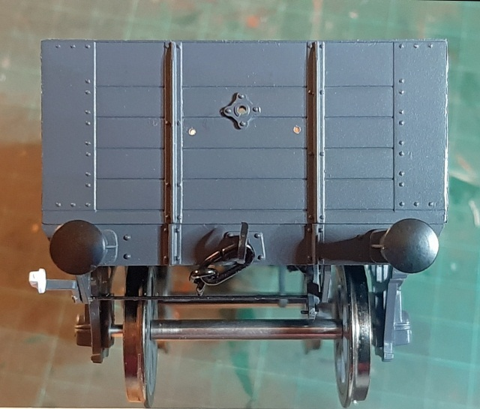

**Step 2 –** Glue the pivot mounting plate over the centre hole. Use a drill bit as guide.

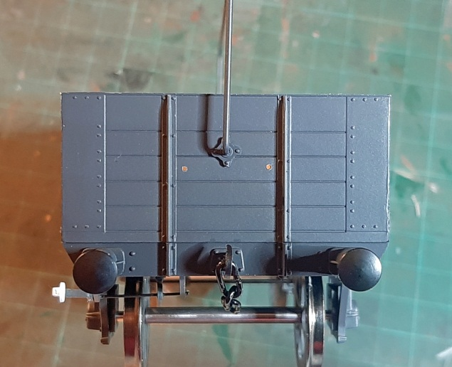

**Step 3 –** Clip the sheet rail into the mounting plates.

Ensure it swings freely.

**Step 4 –** Glue the semi-circular guard rail into the small holes. Glue the plate to the inside of the sheet rail as shown. Ensure the sheet rail swings freely.

