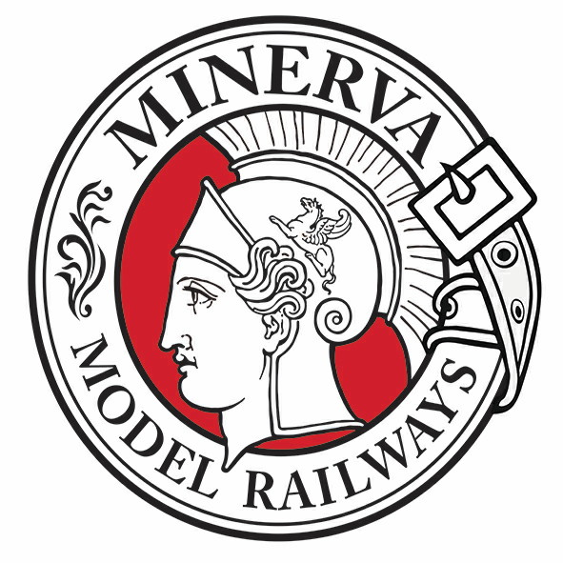
Different ways to order
Call us on the numbers below, email us or print these pages,
fill in the form and send it to the address below
Minerva Model Railways Ltd
PO Box 244
Penarth
CF64 9FJ
Telephone UK: 02920 531246
email: sales@minervamodelrailways.co.uk
website: www.minervamodelrailways.co.uk
Please supply the following 7mm scale N32 model
Mark the box of the model required.
Livery | Price | Quantity
GW 16”  lettering | £62.50 | 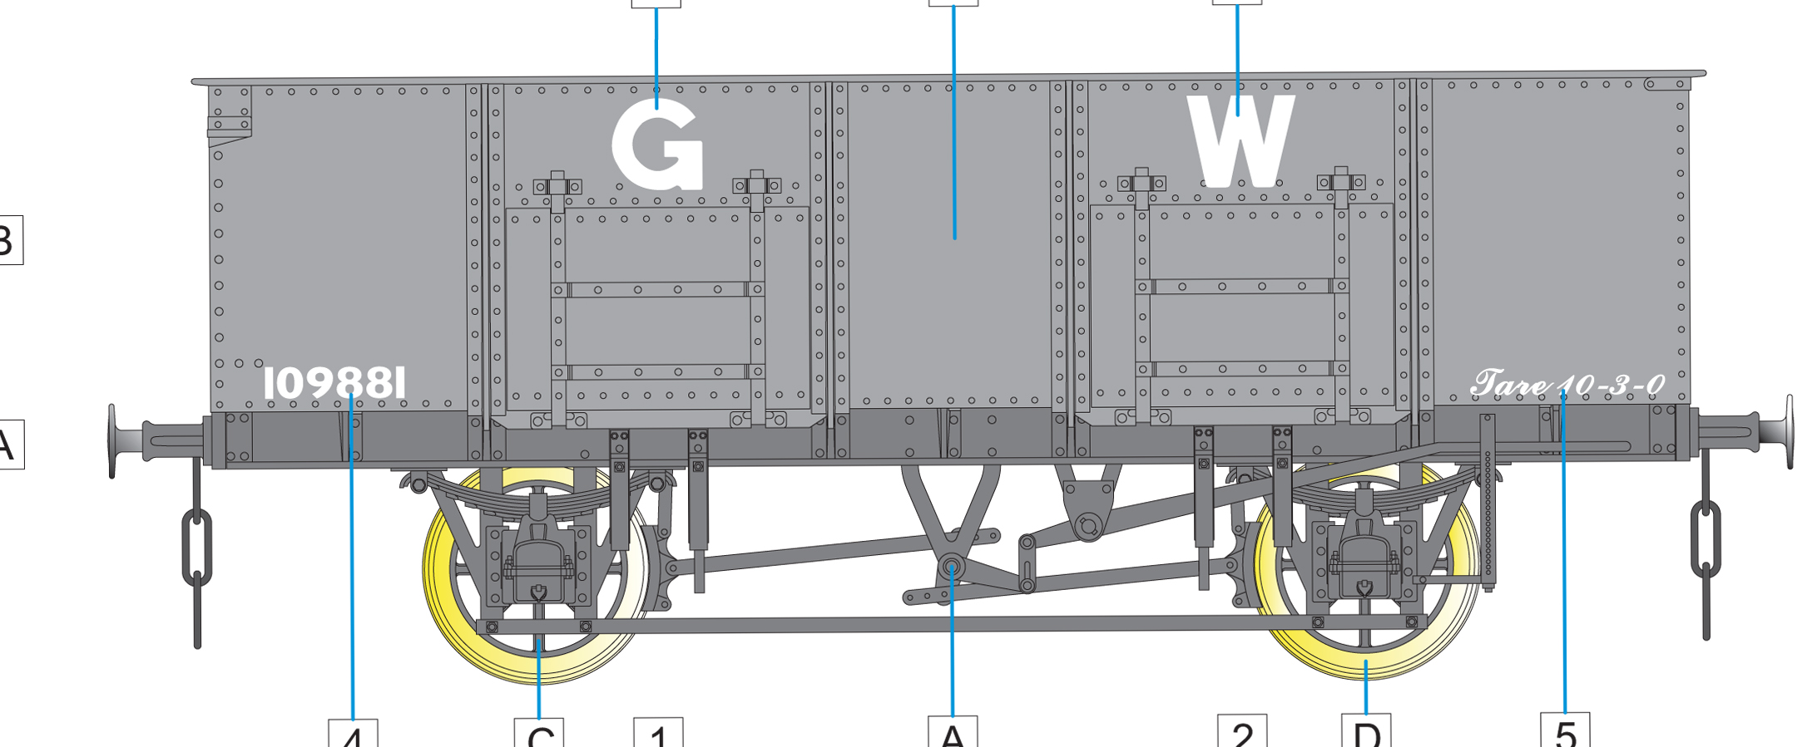
Blaenavon | £62.50 | 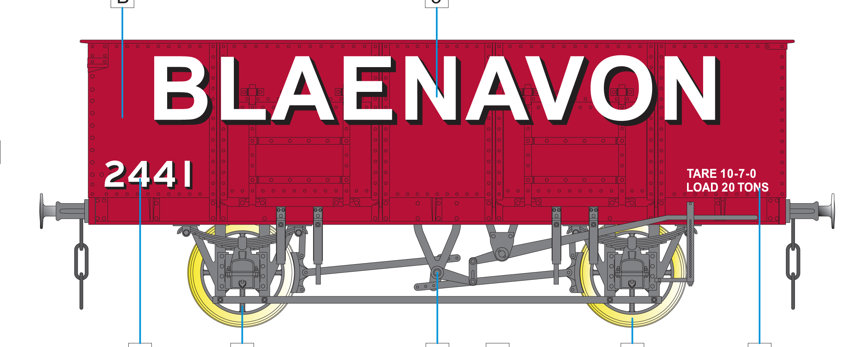
Amalgamated  Antracite | £62.50 | 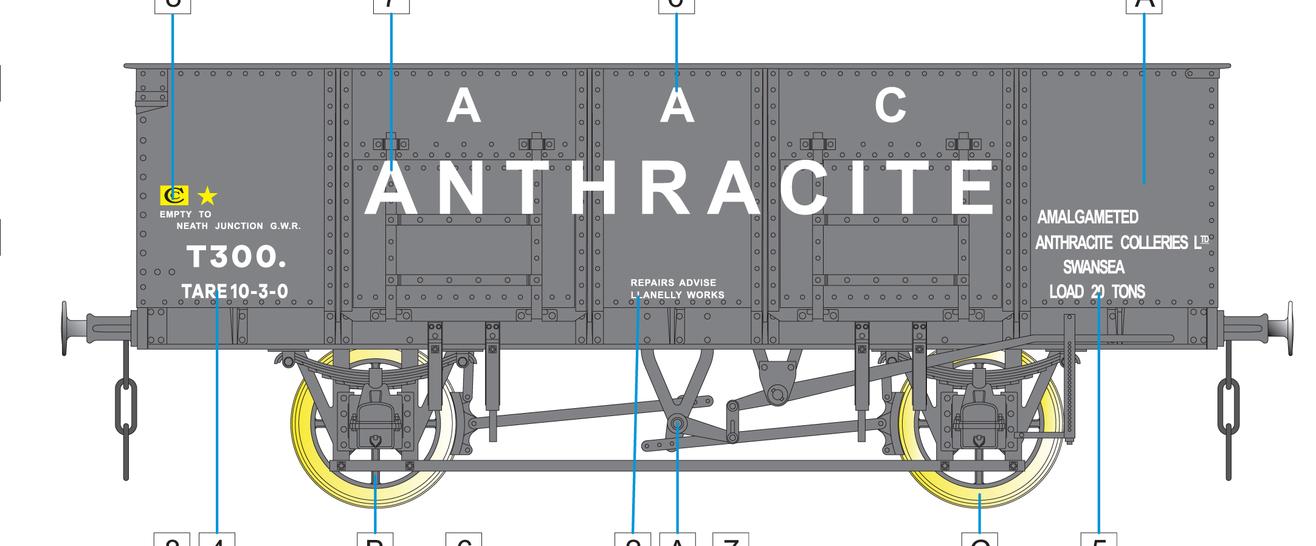
BR Grey | £62.50 | 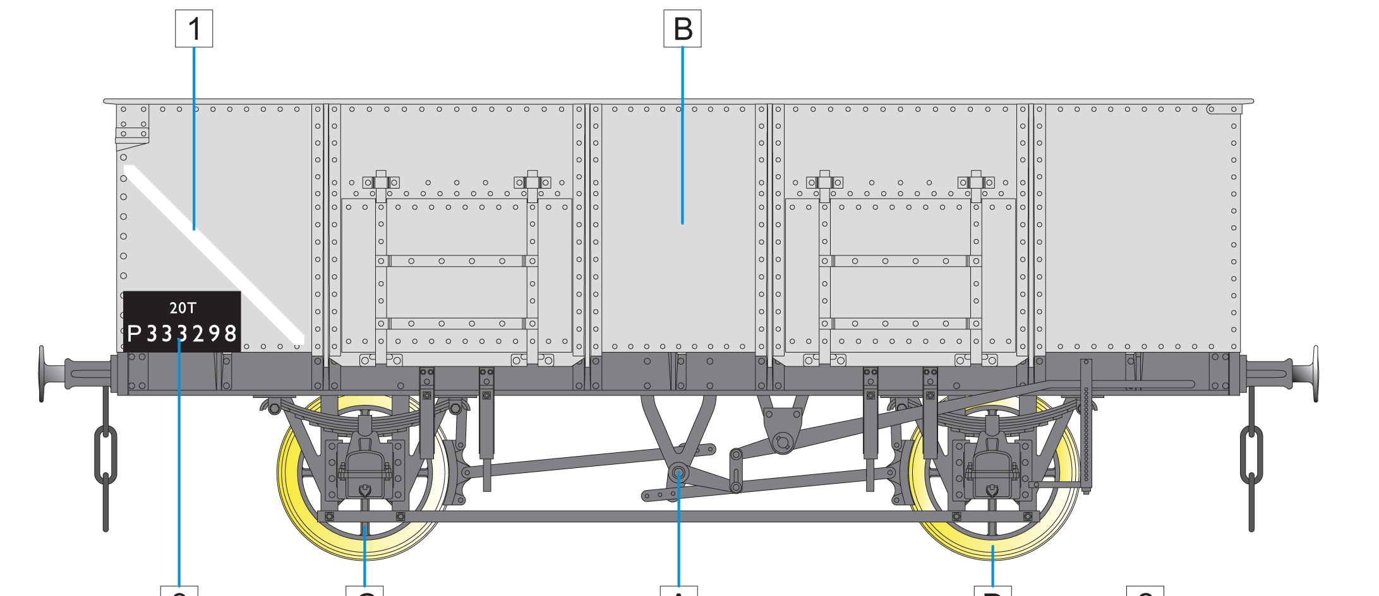

Postage £5.50 per order
Name.............................................................................................................
Address.........................................................................................................
.........................................................................................................
.........................................................................................................
Postcode................................. Tel. Number...............................
Card Number ..................... ....................... .................. .................
Expiry date ...................... Security Number on back ......................
Your card will not be debited until the day of shipment to you.

